Possible Measures:

* Maxflow -> number of possible paths
* Distance to first common parent
* Depth difference
* Similarities in nomenclature
* Number of subsumers
* Number of different axes/concepts traversed

Open points:

* **SNOMED data (.csv with information about graph, https://github.com/antsh3k/Clinical-Coding-Pilot)**
* **Input graph into Python (hint: IDs)**

Reza: Axes // Relations

Kussi: implementation parents

Lars: IDs // attributes

Morten: recursion

Points:

* Deeper knowledge SNOMED – CT // Axes // Relations // IDs // attributes
* What data is necessary?

Label name (ID + PT)

ID: unambiguous, unique – no meaning,

FSN: Fully Specified Name – unique, unambiguous description

Synonym: term to display or select a concept, multiple synonyms per concept possible

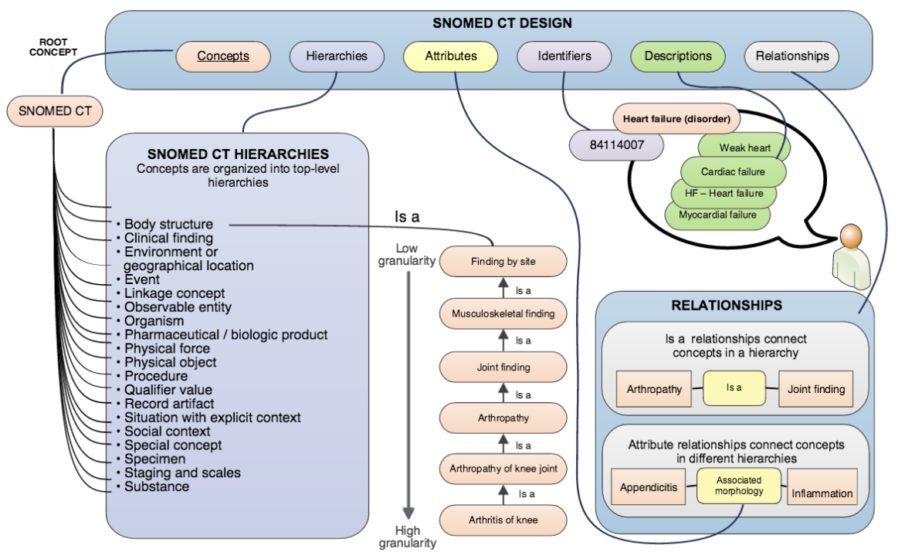

[**SNOMED-CT Starterguide**](https://confluence.ihtsdotools.org/display/DOCSTART?preview=/28742871/47677485/doc_StarterGuide_Current-en-US_INT_20170728.pdf)

[**SNOMED+CT+Document+Library**](https://confluence.ihtsdotools.org/display/DOC/SNOMED+CT+Document+Library)